**CVWO Final Assignment**

**User manual**

1. Navigate to the website: <https://dodo-task.herokuapp.com/>.
2. Click “Sign Up” to create an account using your email address and a password.
3. Log into the account.

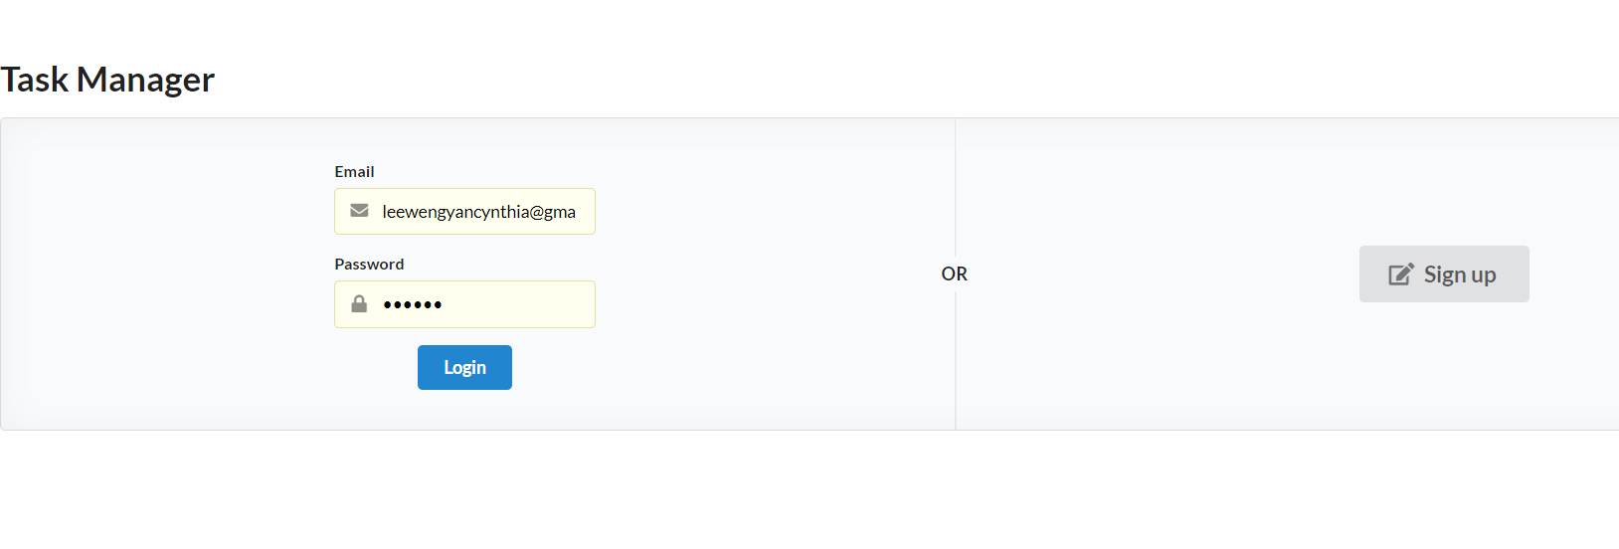

**Managing Task Lists**

1. To create a new list of tasks, click the “Add a new list” button at the top left corner of the main screen.
2. After creating a task list, the user may edit the task list in the following ways:
   1. Edit the name of the task list.
   2. Delete the task list.

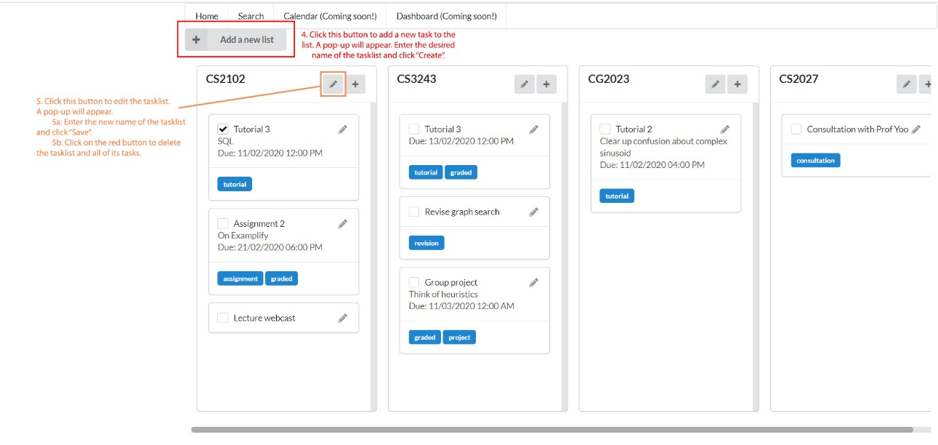

**Adding and editing tasks**

1. To add a task to any list, click the plus sign at the top right of the list. A sliding menu should appear on the left side of the screen. Enter the desired details. Only task name is compulsory, whereas other fields are optional.
2. A task can be tagged so that it can be easily searched and found later on. To create a tag for the task, type the tag and press ‘Enter’. A task can have multiple tags. To remove a tag, click the cross next to it.
3. Click “Create” to add the new task to the list.
4. To edit a task, click the pen icon on the right side of each task card. Task details will be shown on the sliding menu on the left. Change the task details as desired and click “Save” to save the changes.
5. To delete a task, click the red button at the bottom right of the menu.

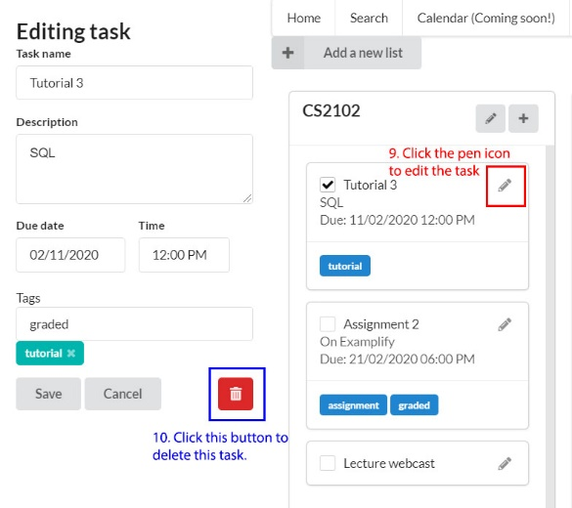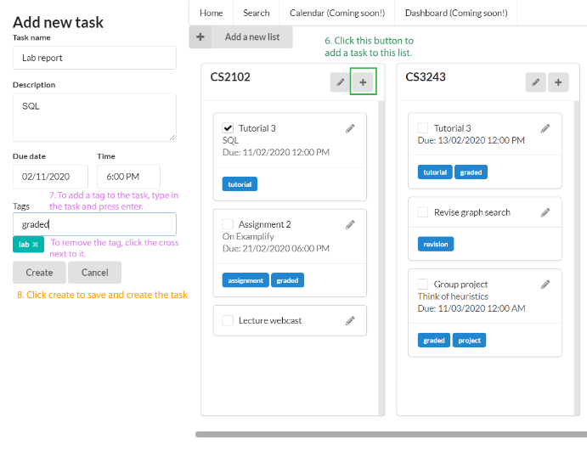

**Searching for tasks**

1. To activate search, click the “Search” button in the top menu.
2. Type in each tag and press ‘Enter’ to input it as a query (similar to tags bar).
3. Click the magnifying glass button on the right to conduct the search.

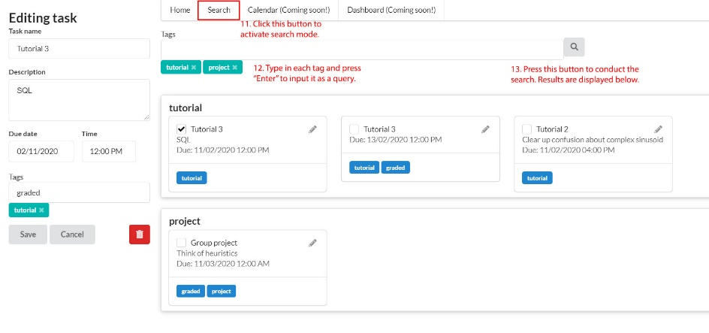

**Write up on accomplishments in the assignment**

In this assignment, I have learnt the basics of web development. Apart from my experience taking the module CS2113 Software Engineering and OOP, this is the second time I have built an application, using new languages and frameworks.

For front-end, I have familiarised myself with React and JavaScript, and I am now able to use React components as well as React lifecycle methods to create complex, interconnected, interactive and responsive user interfaces. I have also learnt how to use UI libraries, namely Semantic UI React, to speed up the design process and capitalise on the reusability of the components. Furthermore, I also tinkered with HTML and CSS to create more personalised and stylised components, such as checkboxes (although I eventually replaced them with Semantic UI checkboxes). For back-end, I have learnt about relational databases and the use of Ruby on Rails to manage them. I found this aspect the most challenging as there was a lot of content to process from reading the Rails guides, and a steep learning curve.

Although I tried to read and understand everything before starting to code, I realised that the best way forward was to try, fail, debug and learn along the way. I also referred to many online guides, tutorials and examples, and consulted online forums or threads for solutions.

Beyond accomplishing the basic requirements, I have also thought about further improvements and functionalities. For example, I have tried to allow users to create user accounts by implementing user authentication. The current implementation makes use of session-based authentication, based on an online reference. Given more time, I would like to gain a deeper understanding of the process, explore token-based authentication, and also provide users with a way to retrieve forgotten passwords. Other ideas include more time-based functionalities (displaying tasks in a calendar, showing overdue tasks, amount of time left before a task is due, etc), and better search functionalities (allow searching with AND and OR logic, filtering and sorting tasks).

As a beginner, learning web development has been extremely challenging and daunting for me. Given the large amount of content to digest and process, as well as the fact that I was working on this project independently, there were many times when I felt that I wanted to give up on the assignment. However, with the desire to improve myself and learn new things, as well as encouragement from my friends, kept me going despite the difficulty. Beyond the coding aspect, I believe I have also learnt how to learn more quickly and efficiently through trying and experiencing rather than simply trying to absorb information. I have also learnt how to be resilient when faced with problems, and resourceful when solving them.

Although I have learnt a lot, I feel that I have only barely scratched the surface of web development. Nevertheless, I am proud of the progress I have made, and I would definitely continue learning and expanding on the aforementioned ideas in my own time. Regardless of the result, I am glad that I attempted this assignment.